GOVERNMENT DEGREE COLLEGE, GUMMALAKSHMIPURAM
DEPARTMENT OF HISTORY 2023-24
Savitribai Phules Birth Anniversary
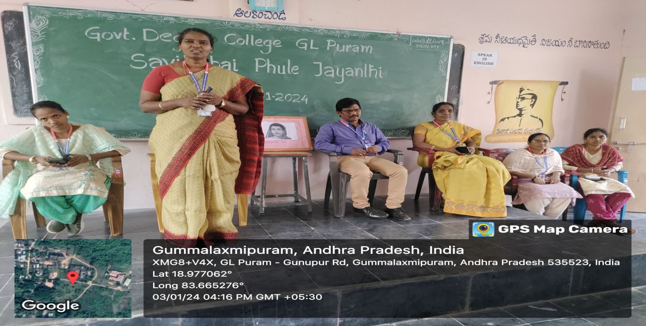
Savatribai Phule’s Birth Anniversary celebrated in the college on 03-01-2024. The Guest of honor Smt. Dr. T. Sreevaram Garu, Principal of the college, delivered a message on the Importance of Savitribai Phule's life history and Achievement. All the staff and Students participated in this programme.

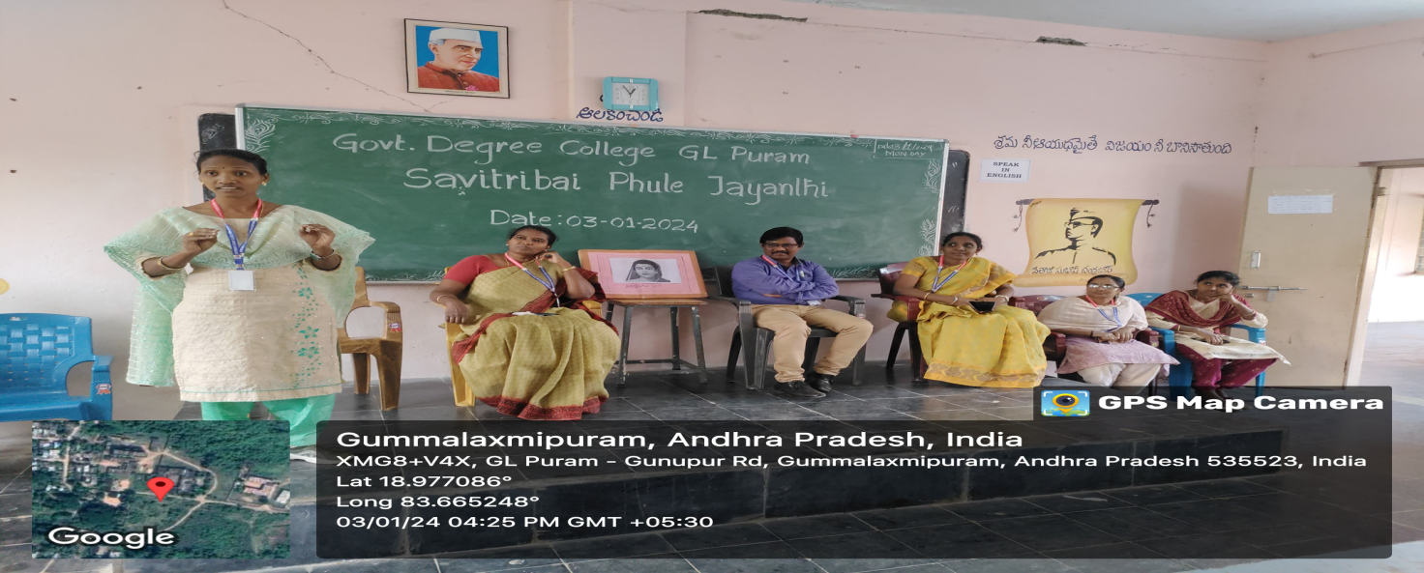

Student Speech
Respected Lecturer , honorable guests, and my dear friends,

Today, I am honored to speak about a great social reformer, educationist, and the mother of women’s education in India—Savitribai Phule. She was not just a teacher but a revolutionary who dedicated her life to educating women and fighting against social injustices.
Born on January 3, 1831, in Maharashtra, Savitribai Phule faced many challenges in her quest to educate girls. At a time when education for women was considered unnecessary, she, along with her husband Jyotirao Phule, took the bold step of starting the first school for girls in 1848. Despite facing criticism and humiliation, she remained determined to uplift women through education.

